Minority Rights Resolution Issue Sheet

Resolution: The land title of indigenous groups in the United States shall be expanded to encompass all traditional territory controlled by that indigenous group, even if that group was semi-nomadic.[1] This would bring the United States into line with international best practices, exemplified by Canada’s Indigenous People’s Act and upheld in the 2014 Supreme Court of Canada decision, *Tsilhqot'in Nation v British Columbia* [2014 SCC 44](https://www.canlii.org/en/ca/scc/doc/2014/2014scc44/2014scc44.html).

Sponsor: Difference Liberal Faction

Commentary: “Because the state cannot be neutral with respect to culture, it has a special duty to protect the property rights of indigenous peoples. This resolution will reduce the normalizing effect of non-ownership on disadvantaged groups, and go some way towards rectifying unchosen inequalities.”

Status: This resolution, or a version of it, must be voted on by the close of the third legislative session unless the assembly, by majority vote, chooses to consider a different resolution.

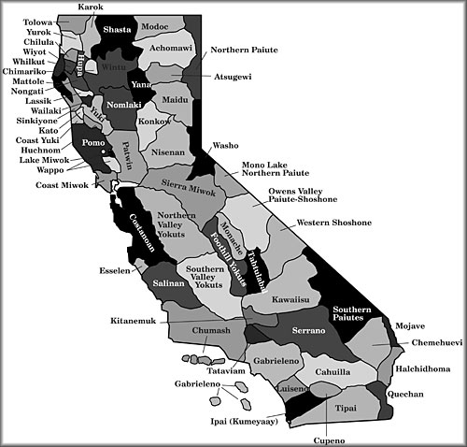

1. Much of the Western United States, including more than 40% of Arizona, California, Idaho, Oregon, Montana, Nevada, New Mexico, Utah and Washington would be returned to native ownership.